- converting the pixel values in the binary form (sequence of bits)
- dividing bits into bit planes.

Notes:
- Number of bit-planes is the maximum size of bit sequences.
- Size of bit-planes must be same as size of image

So for a 8bit image, you have to consider 8 planes and for 3bit image, 3 planes.

For simplicity, take a 3×3, 3-bit image as shown below.
We know that the pixel values in 3bit image, are between 0 to 7 (so we can store 8 colors for each bit).

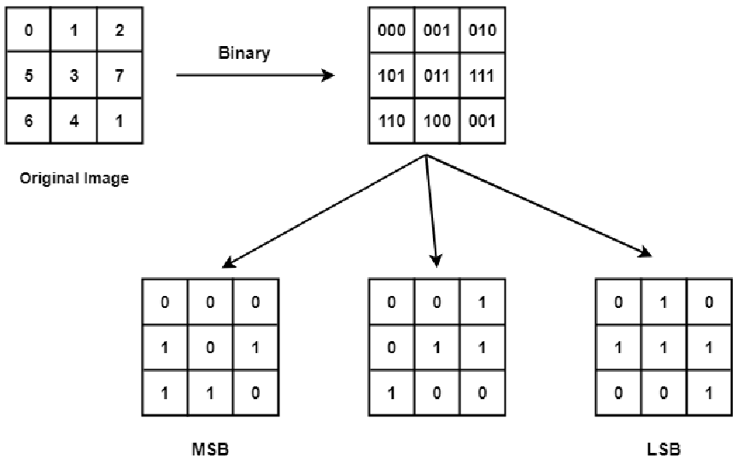
As you can see, each bit-plane is a binary image and size of all of them is same as original image.

For a 8 bit image of 100 dollars (uint8 in MATLAB and Octave) we have these:
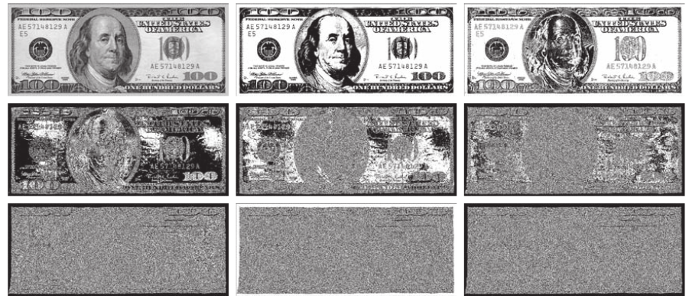

Intensity of gray border of image is 194 which its binary representation is 11000010. Now we can guess the color of border of image in each bit-plane. In the first, second and 7th bit-planes, bits of border are 1 and as bit-planes are binary images, in those bit-planes color of the border must be white. For other bit-planes bits of the border is 0 so color must be black.

Example: getting 8th bit-plane

> dollar=rgb2gray (imread("orig_100_dollars.png"));
> figure;imshow (dollar)
> plane_8=mod(fix(double(dollar)./128),2);
> figure;imshow (plane_8)

What I got, although very differs from what the book displays as result for 8 bit-plane :

I got this by using GIMP and thresholding for 128:
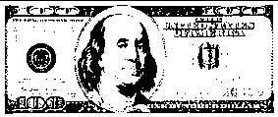
So it seems that what I got is true!

Note:
For getting integer part of quotient in integer division, you have to convert both operands of division as double.

Example: getting all 8 bit-planes from 8bit image

> plane_8=mod(fix(double(dollar)./128),2);
> figure;subplot(4,2,1);imshow (plane_8);title("8th bit-plane")
> plane_7=mod(fix(double(dollar)./64),2);
> subplot(4,2,2);imshow (plane_7);title("7th bit-plane")
> plane_6=mod(fix(double(dollar)./32),2);
> subplot(4,2,3);imshow (plane_6);title("6th bit-plane")
> plane_5=mod(fix(double(dollar)./16),2);
> subplot(4,2,4);imshow (plane_5);title("5th bit-plane")
> plane_4=mod(fix(double(dollar)./8),2);
> subplot(4,2,5);imshow (plane_4);title("4th bit-plane")
> plane_3=mod(fix(double(dollar)./4),2);
> subplot(4,2,6);imshow (plane_3);title("3th bit-plane")
> plane_2=mod(fix(double(dollar)./2),2);
> subplot(4,2,7);imshow (plane_2);title("2th bit-plane")
> plane_1=mod(fix(double(dollar)./1),2);
> subplot(4,2,8);imshow (plane_1);title("1th bit-plane")

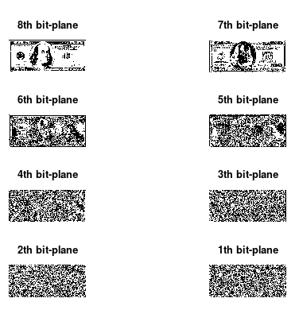

Example: Composition of bit-planes

> comp= plane_8*2^7 + plane_7*2^6 + plane_6*2^5 + plane_5*2^4 + plane_4*2^3 + plane_3*2^2 + plane_2*2^1 + plane_1*2^0;
> comp=uint8(comp);
> figure;imshow(comp);title ("composition of all bit-planes")

Result is the same as original 100 dollars image:

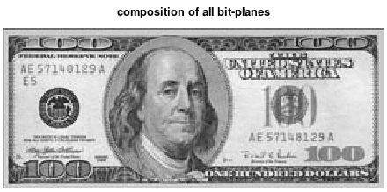

Note:
As class of all bit-planes is double, sum of them also will be of class double too. But result of summations are really integers in [0,255] and may be greater than 1. So you have to convert its type from double to uint8 by running comp=uint8(comp) command. Else you will get a black-white image.

